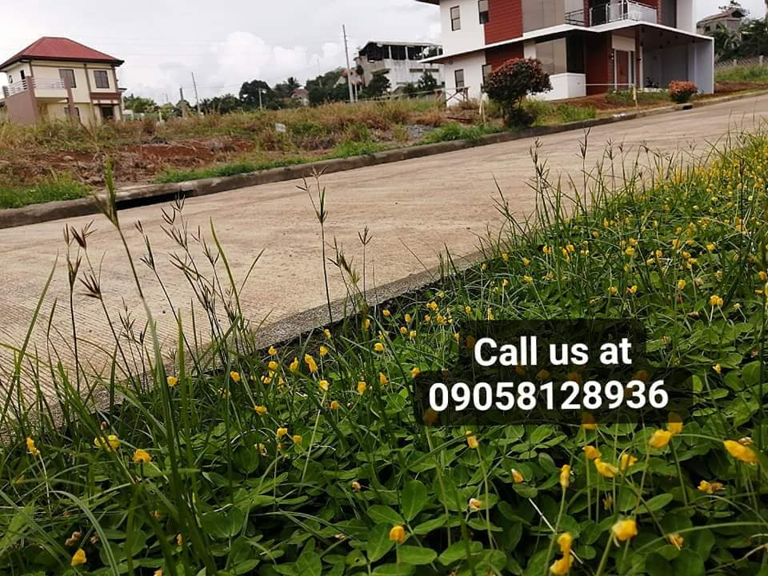 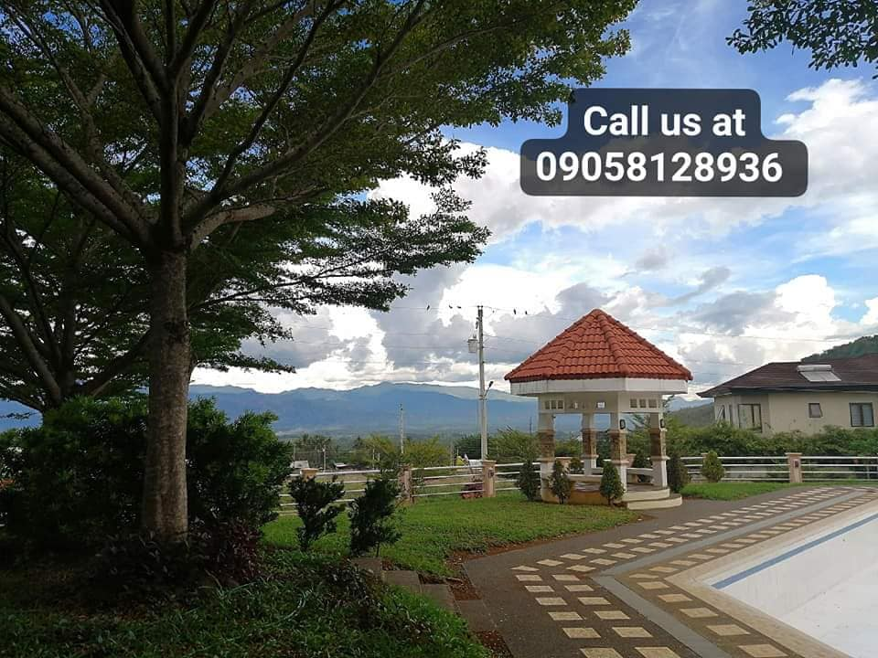   
  
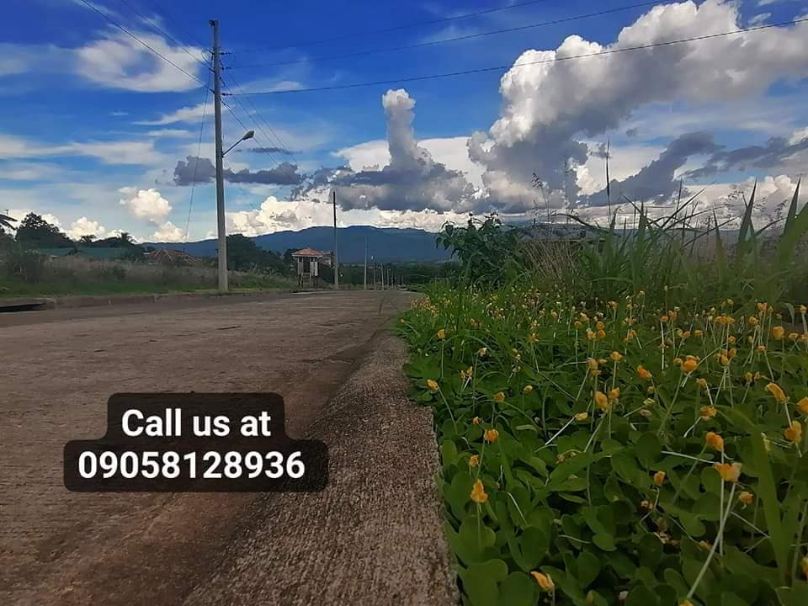 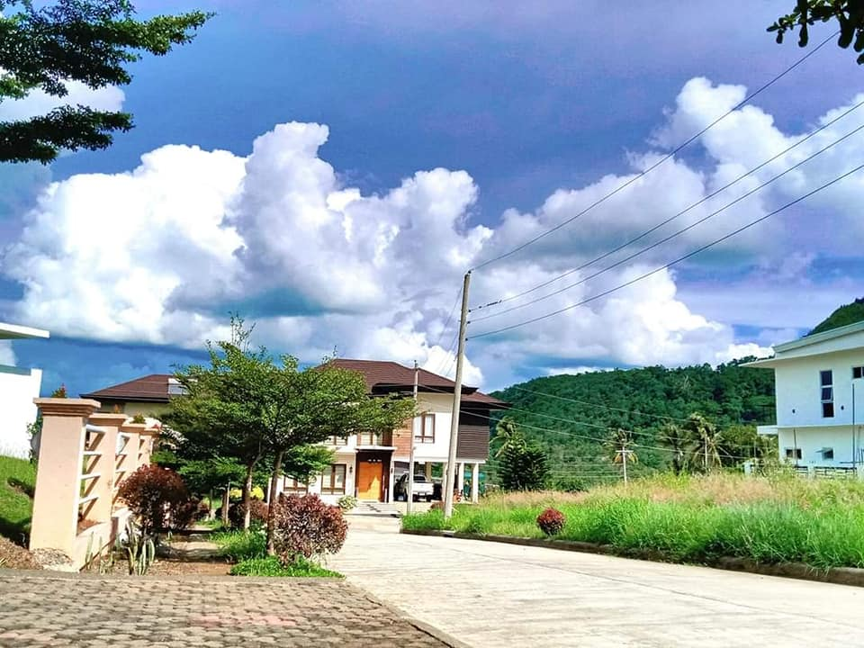   
  
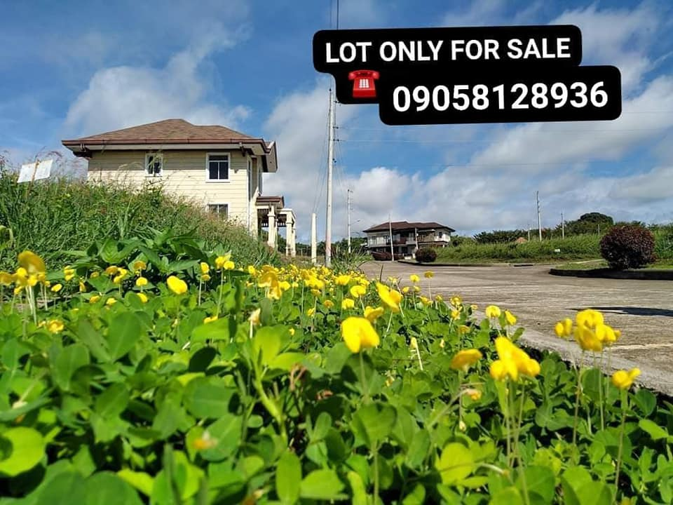 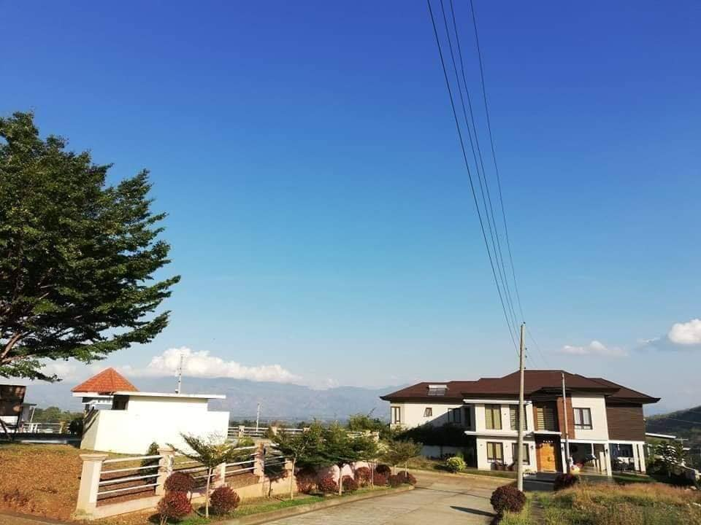

**VALENCIA ESTATES**

A High -End Subdivision in Valencia City

We offer lot only:

Regular cut: 150sqm

* Price : 1.5M
* 2,778 ra ang montly sa imo EQUITY FOR 18 MONTHS.
* RESERVATION FEE IS 100K.

If you avail the spot cash down payment you will have a discount of 15% for the total price .

Save as much as 225k

* Remaning 90% balance is through bank financing.

Amenities :

* Swimming Pool
* Guarded 24/7
* Guarded Entrace w/perimeter fence
* Basketball Court
* Clubhouse

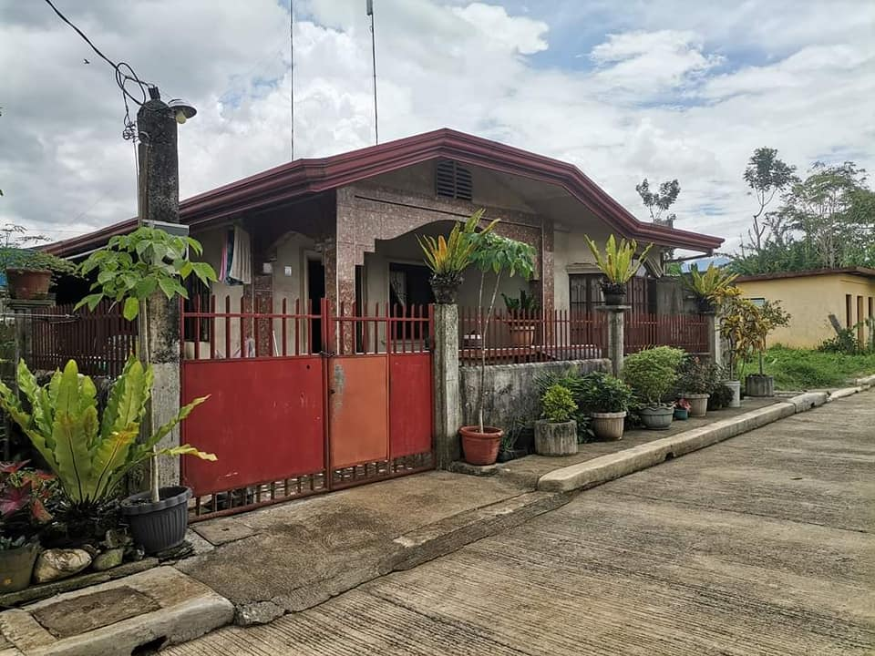 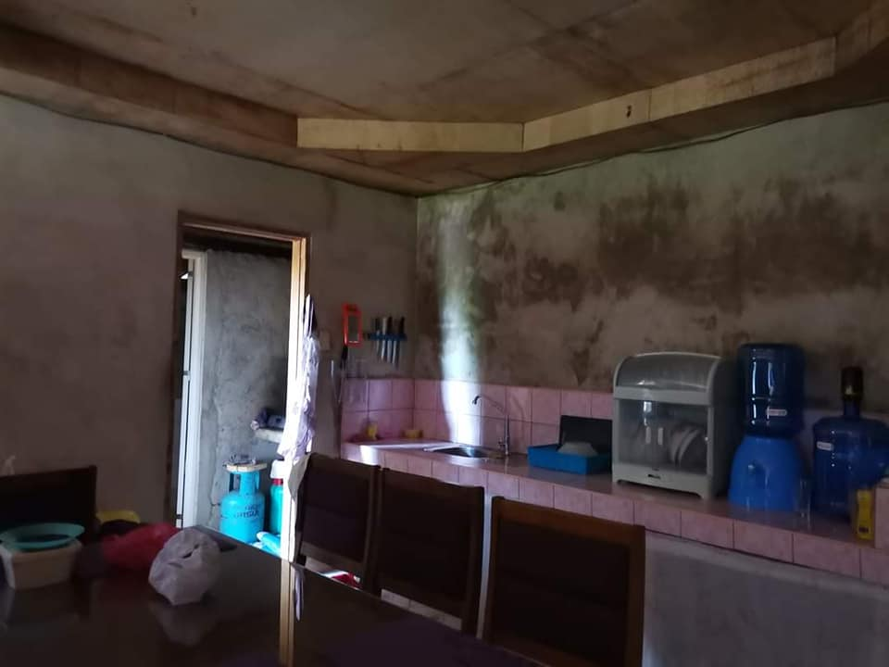

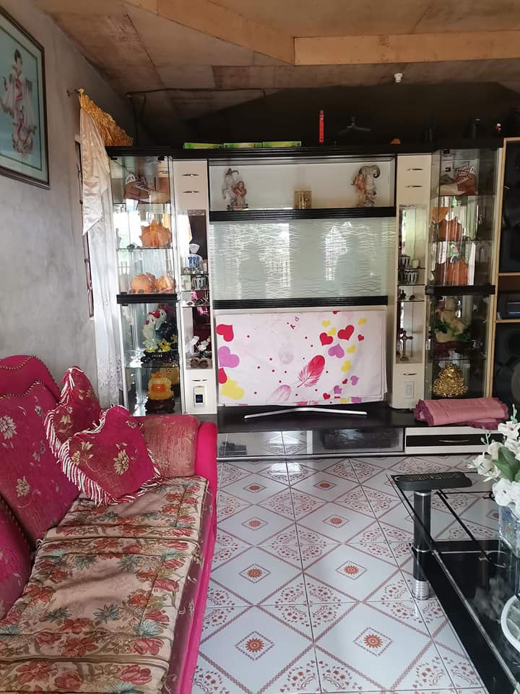 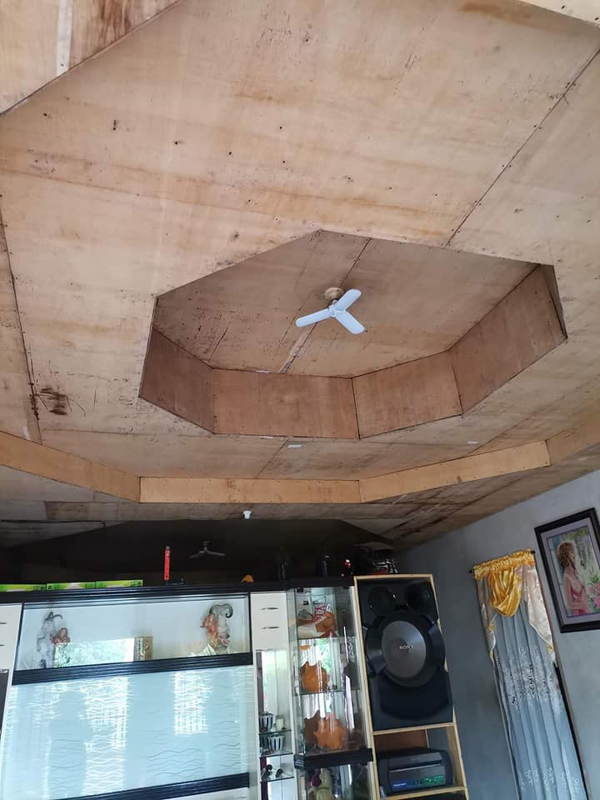 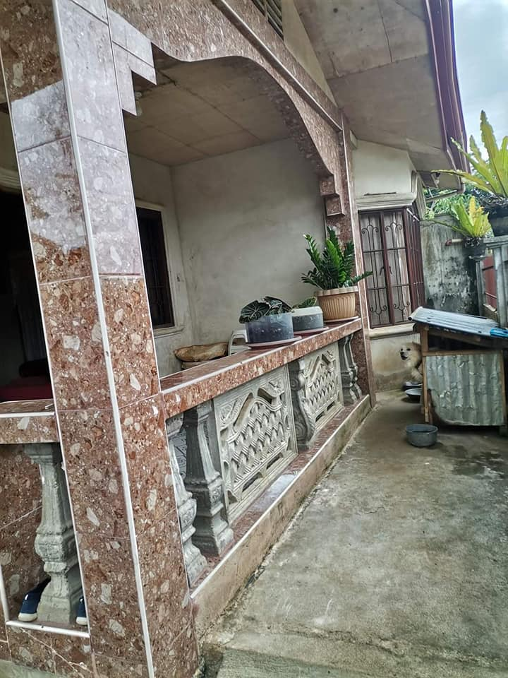

House and Lot for Sale inside an Exclusive Subdivision

Location: Malaybalay City

Lot Area: 120 sqm

* With balcony
* 3 bedrooms
* 1 masters bedroom with toilet and bath
* Floor tiles
* With water tank
* Gated with concrete fence

Reason for Selling: Transfer of Residence

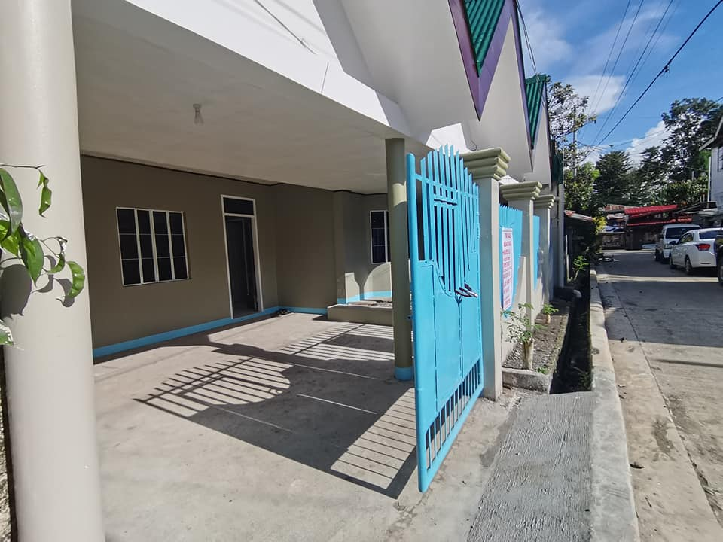 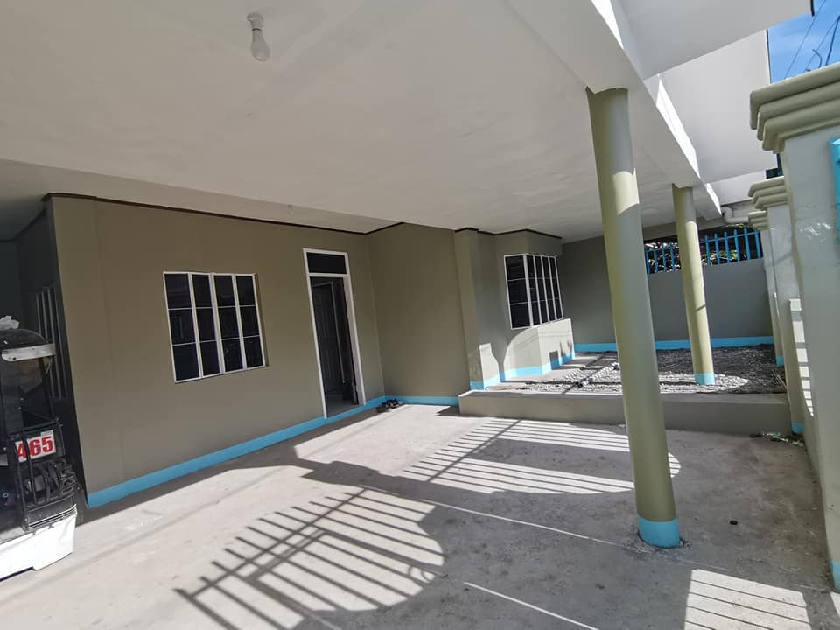 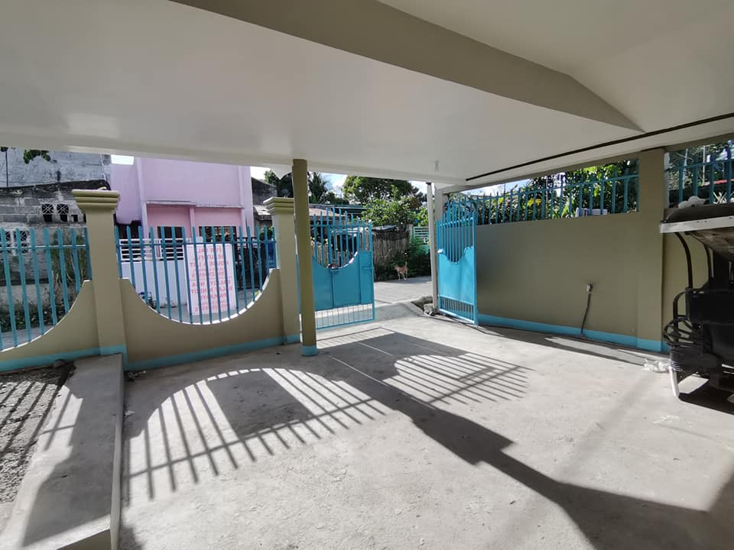

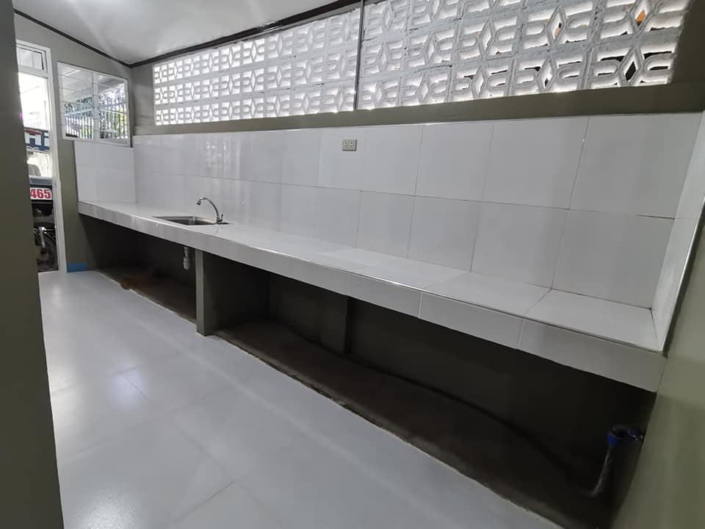 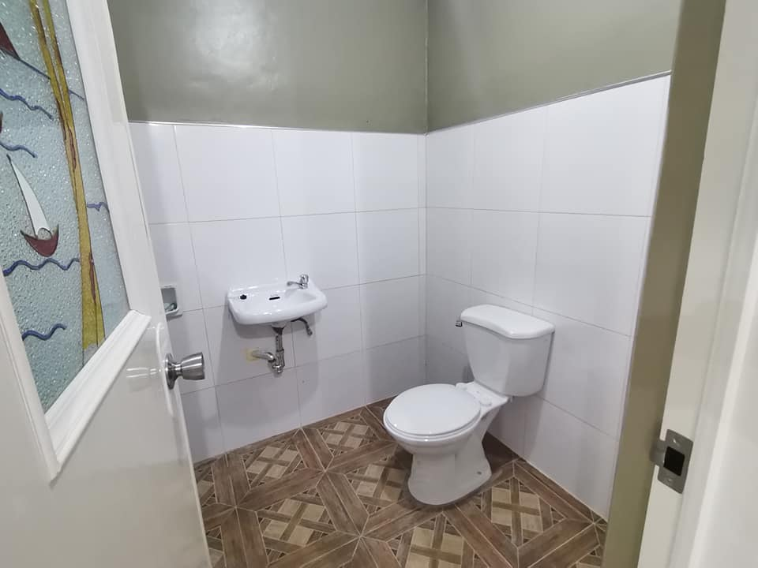 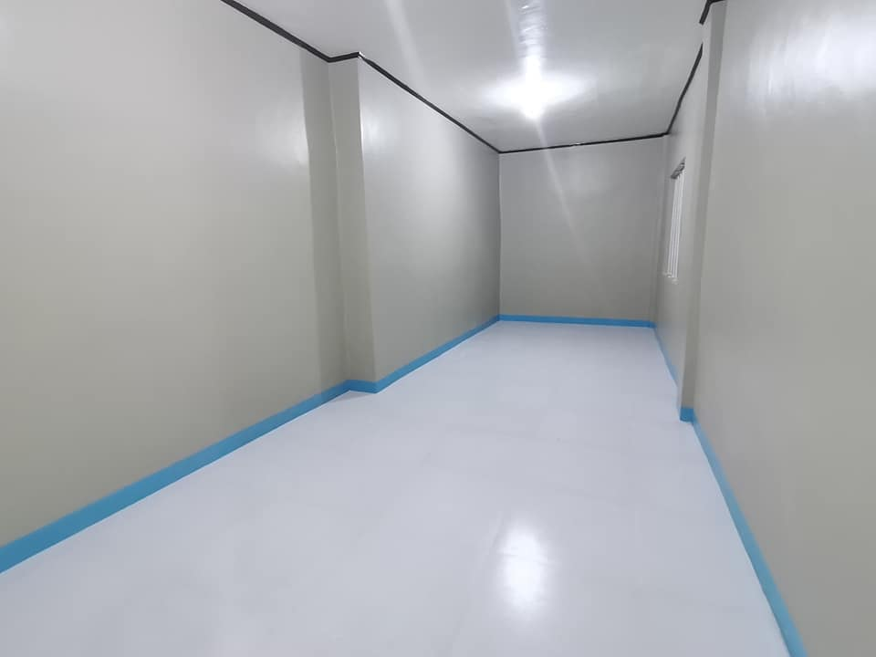

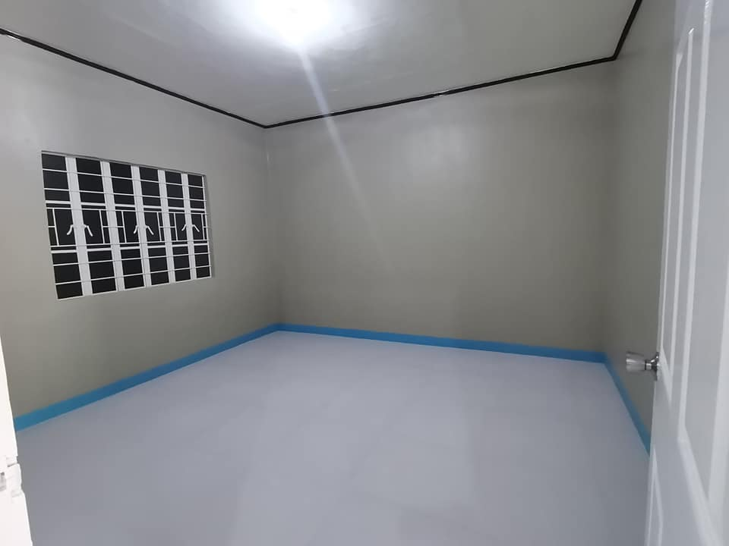 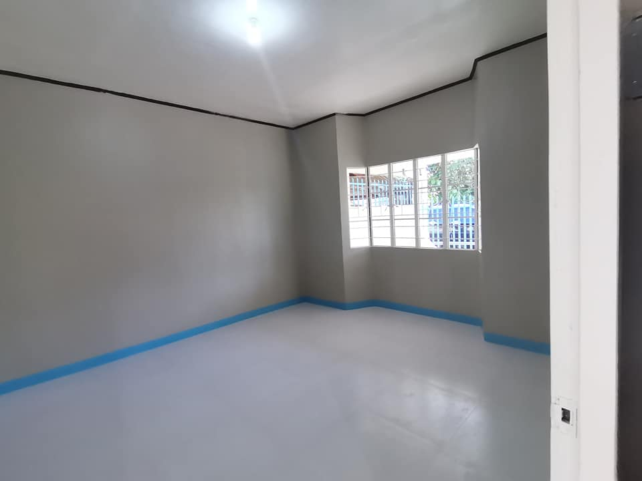 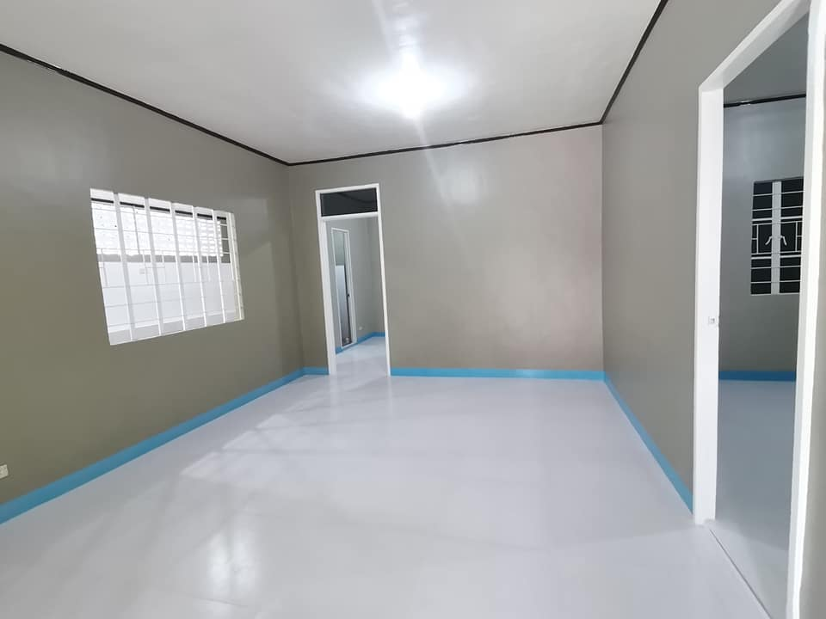

FOR SALE: House and Lot

Location: Kubayan phase 1, Malaybalay City, Bukidnon.

Price: 2.6M

* Large home on 140 sqm
* Large cover garage
* Active water and electric
* New paint
* New tiles in whole house
* New house wiring
* Two wide bedrooms
* Wide dining area, can make another extra room
* New bathroom and kitchen
* Super lume roofing

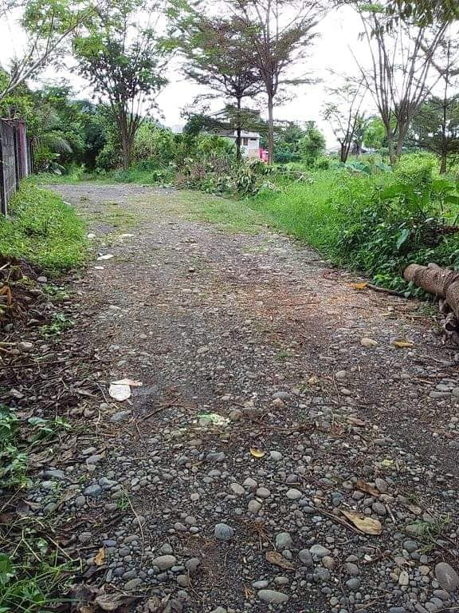 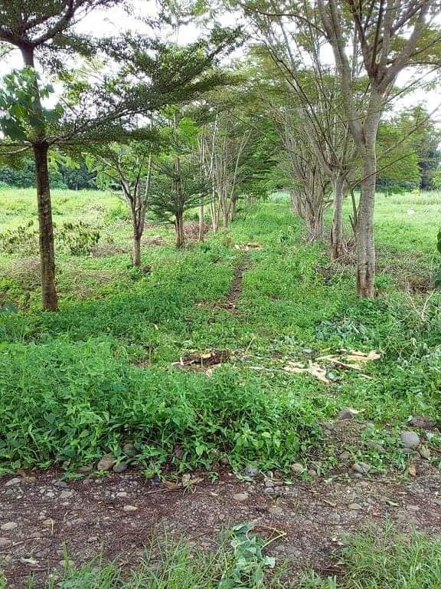

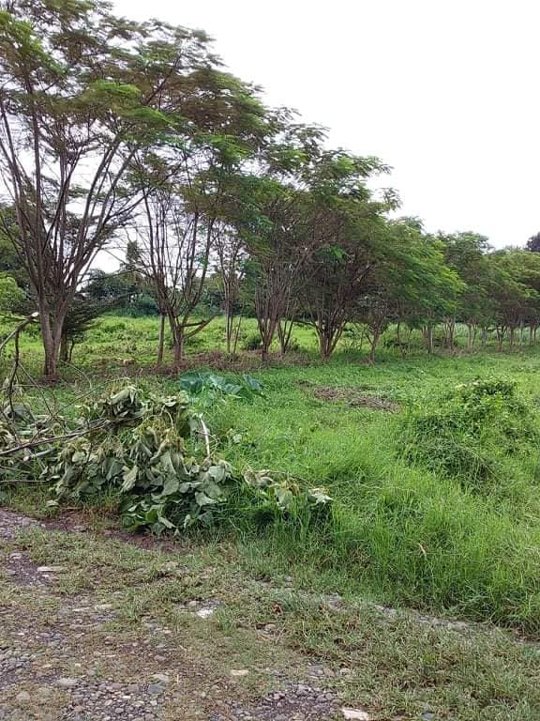 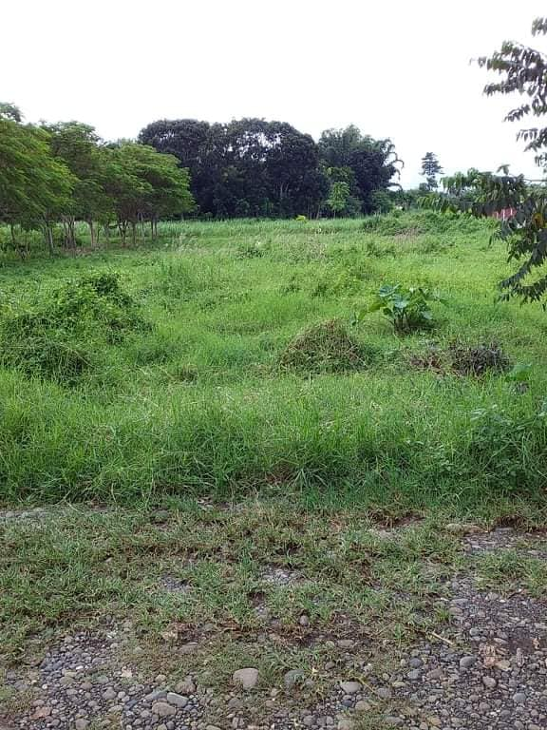

LOT FOR SALE!  
Location: Barangay Lumbo, Valencia City.  
(Very near Valencia Estates. Walking Distance from National Highway.)  
Lot Area: 300sqm and 400sqm

* Clean title
* Ready to transfer

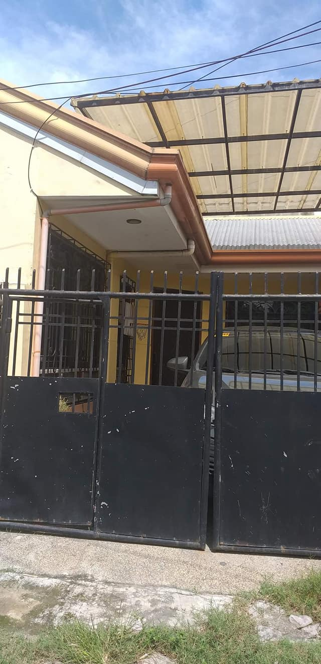 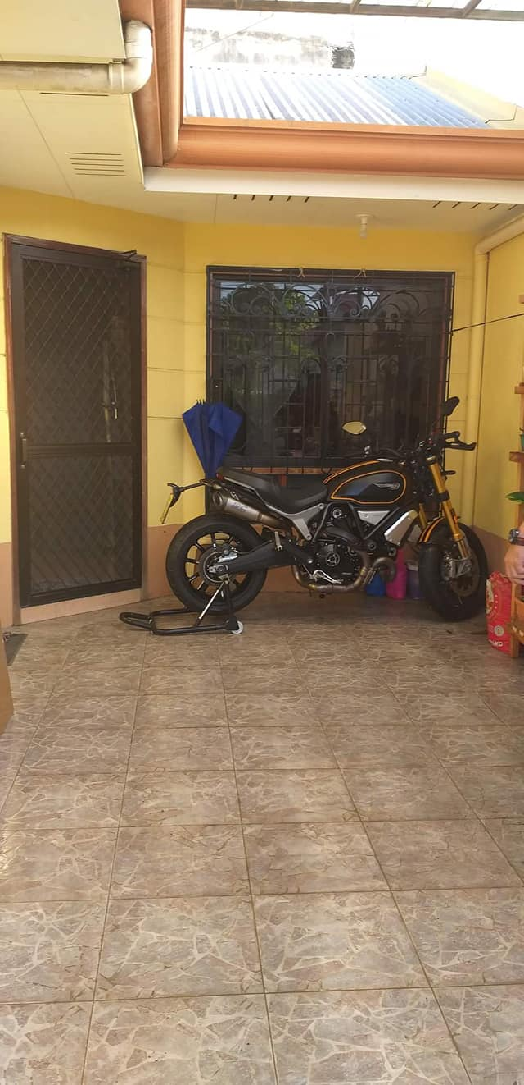 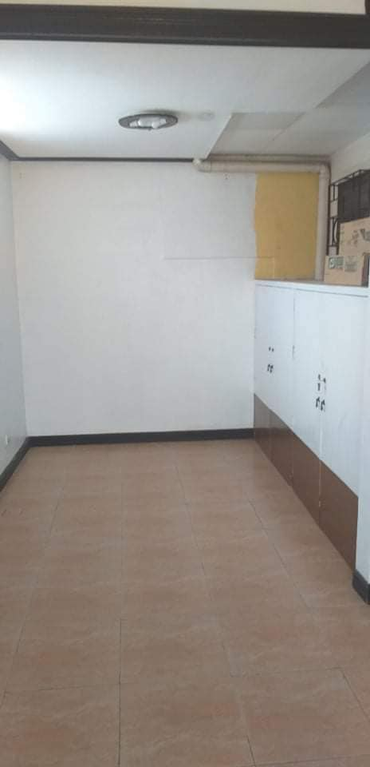 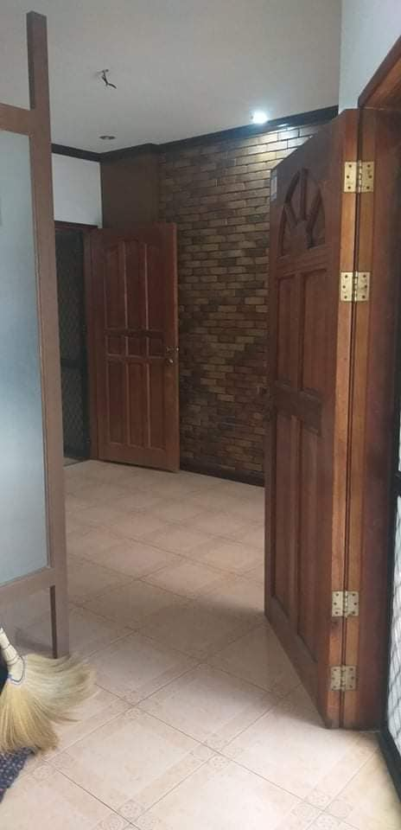  
  
 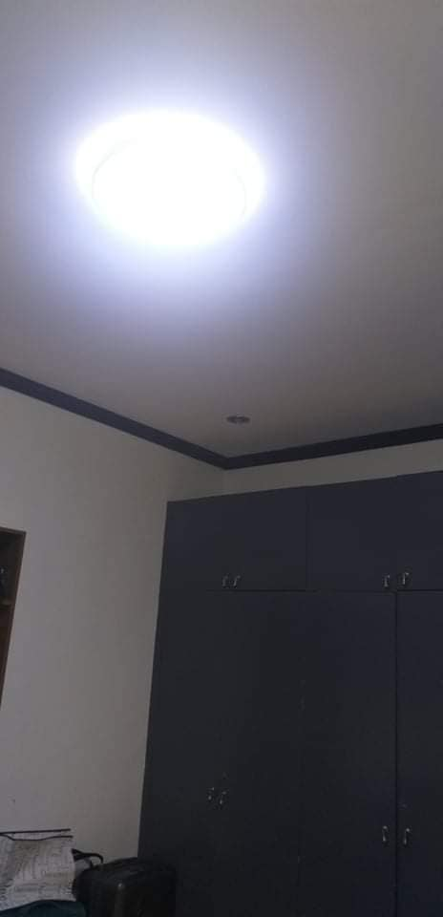 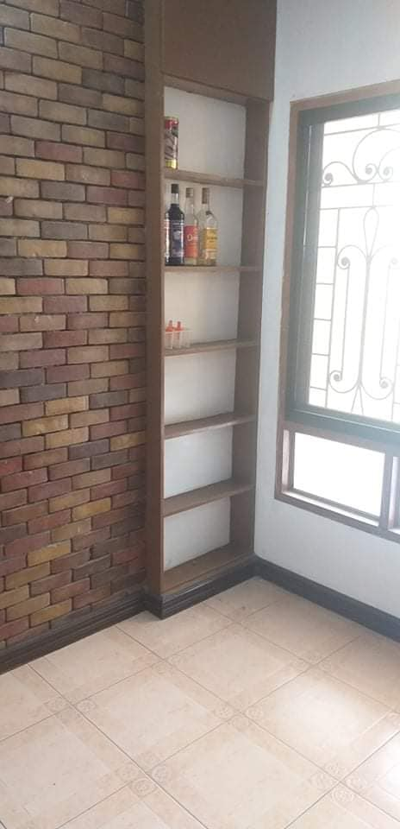 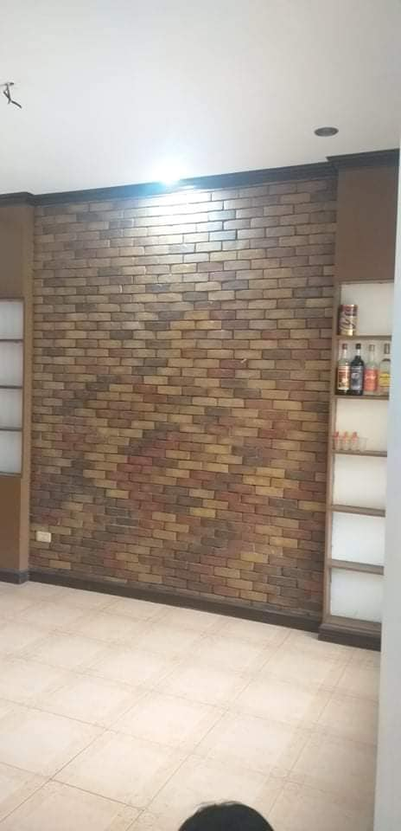 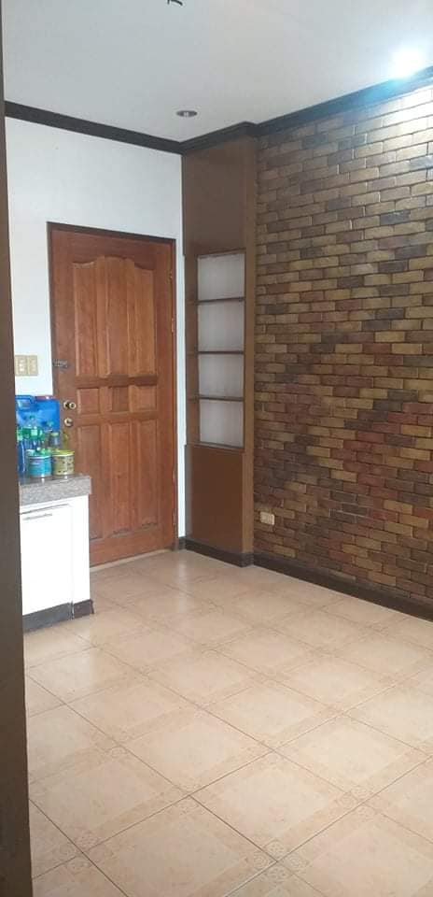  
  
 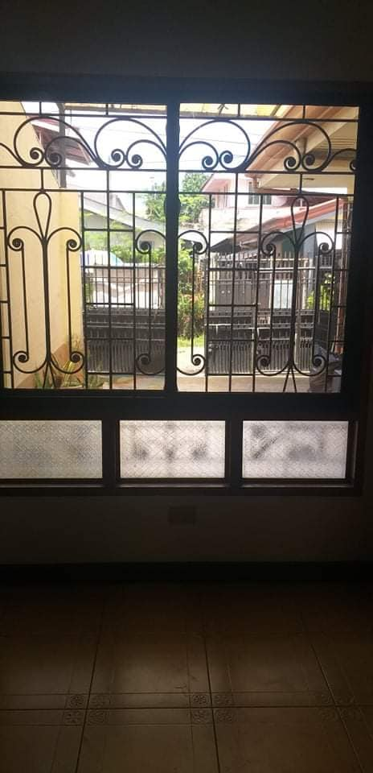 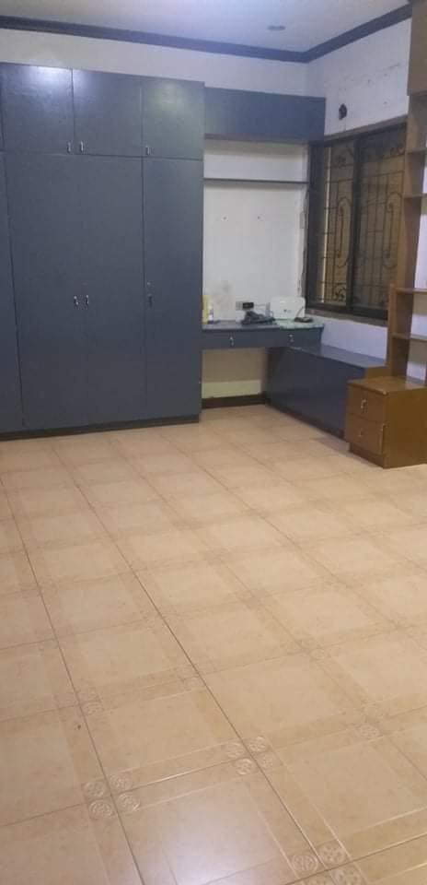 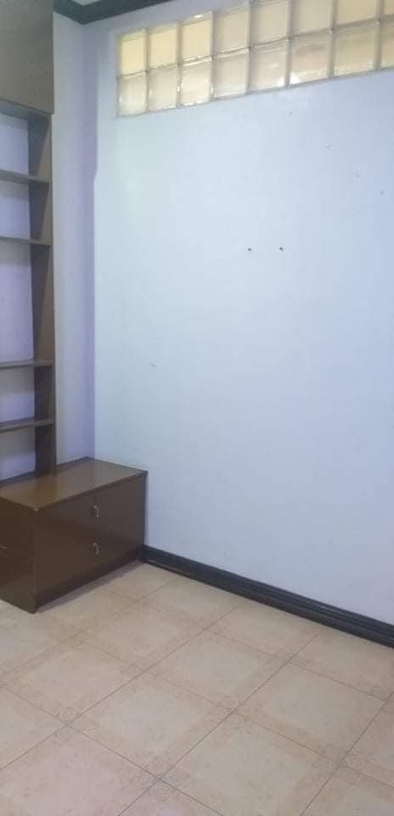 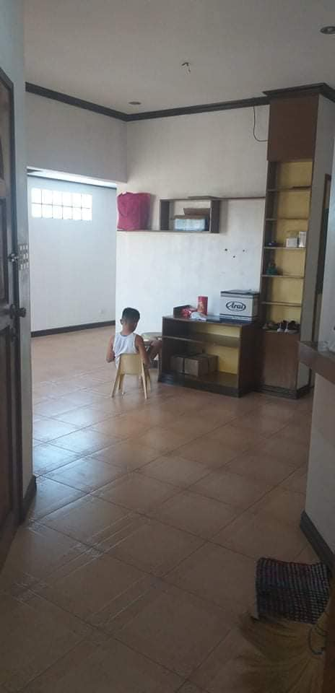

House and Lot for sale located in Johndorf Subd, Barra, Opol Mis Or

Price : 2.2M, clean title

Lot area : 100sqm

Floor area: est 90sqm

2bedrooms, 1 toilet and bath

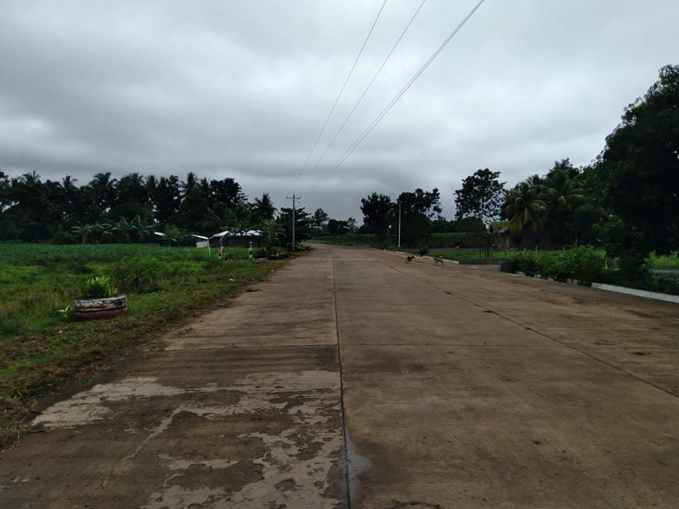 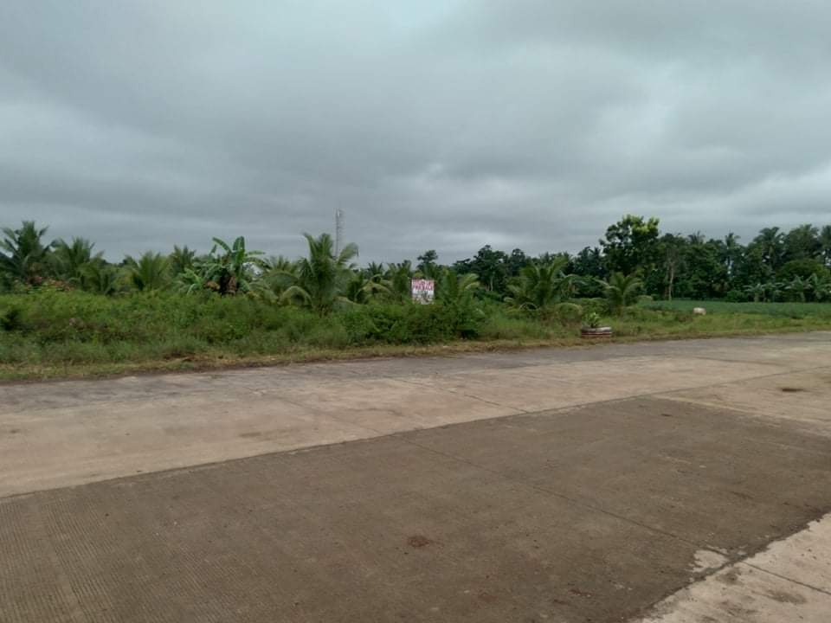

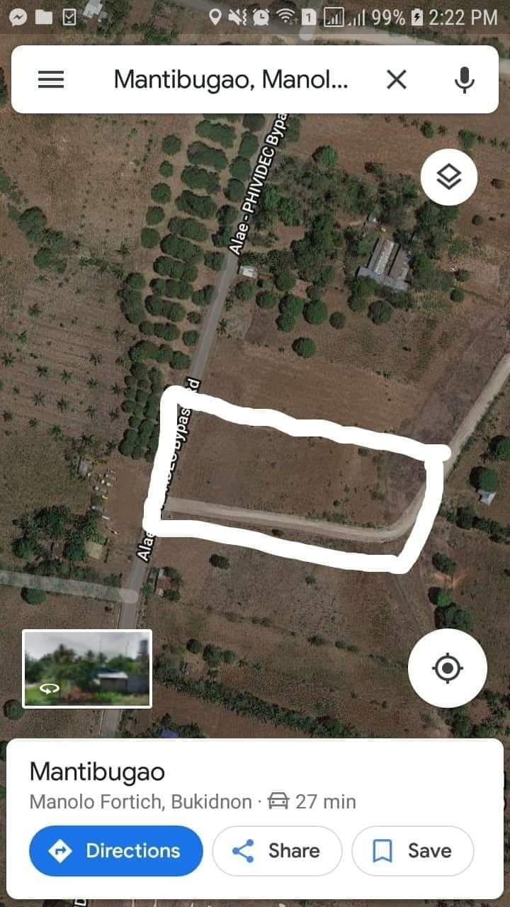

LOT FOR SALE  
Location: Mantibugao, Manolo Fortich

* 7,113 sqm
* Very Wide frontage
* Corner lot
* Ideal for gasoline station / commercial use
* Very affordable price

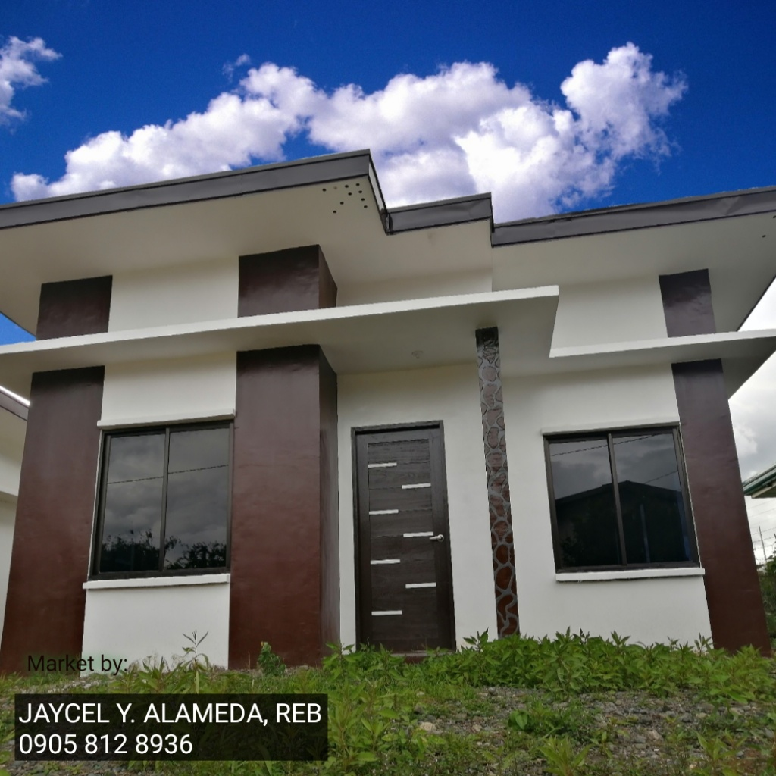 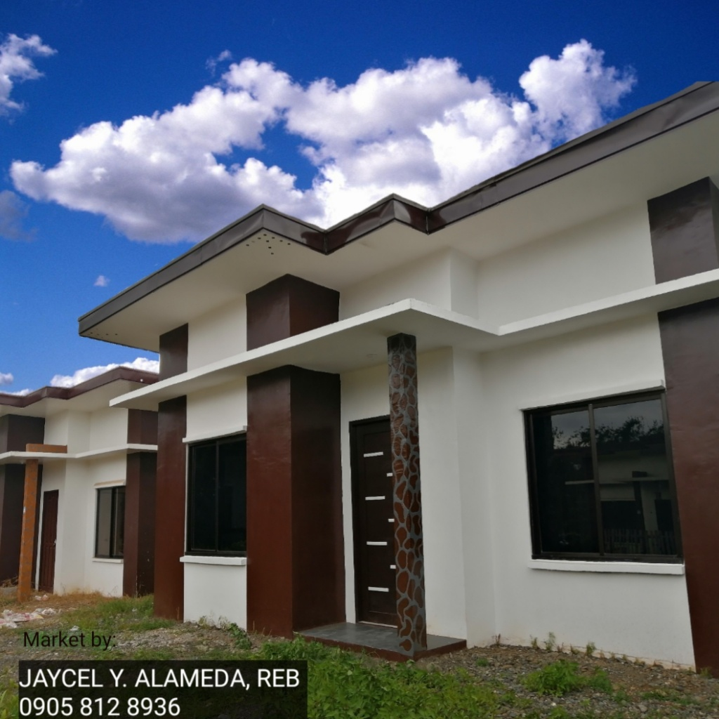

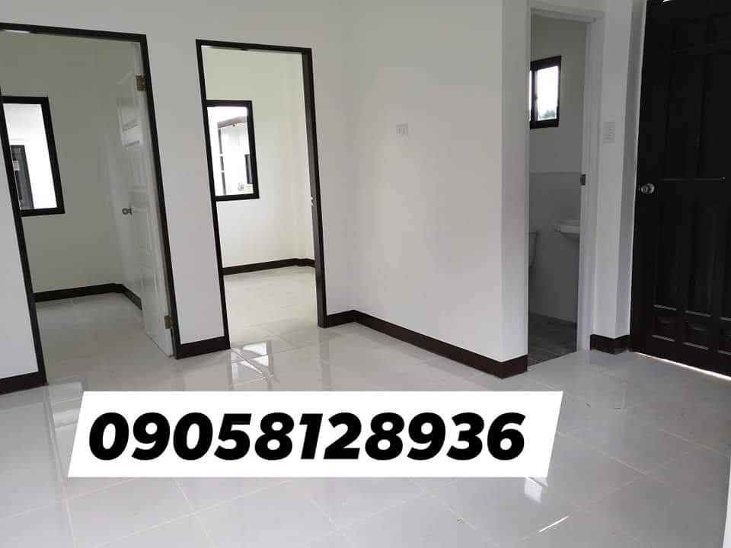 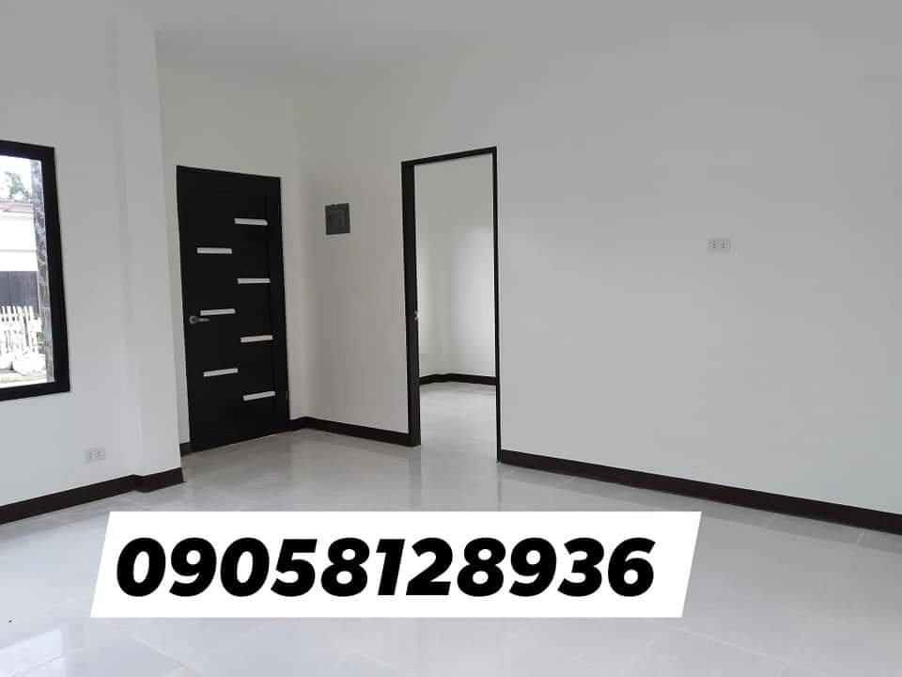 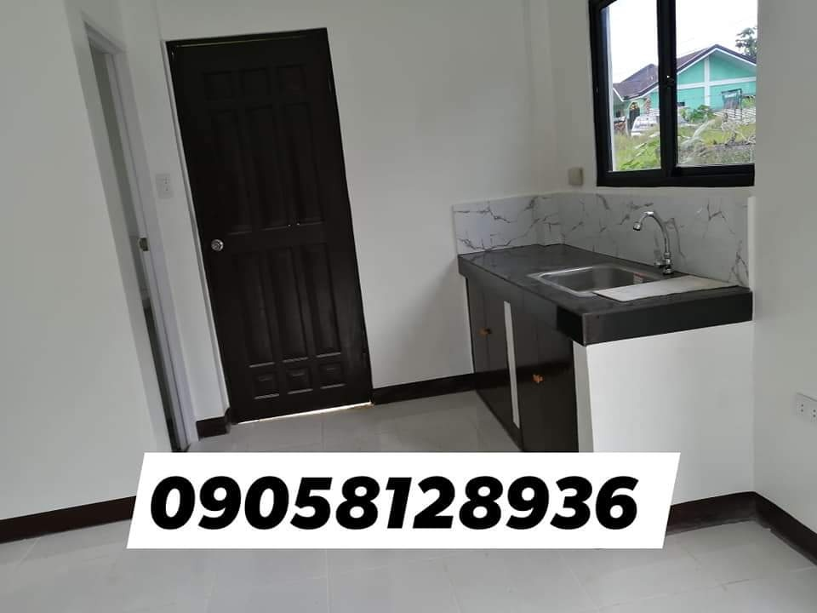

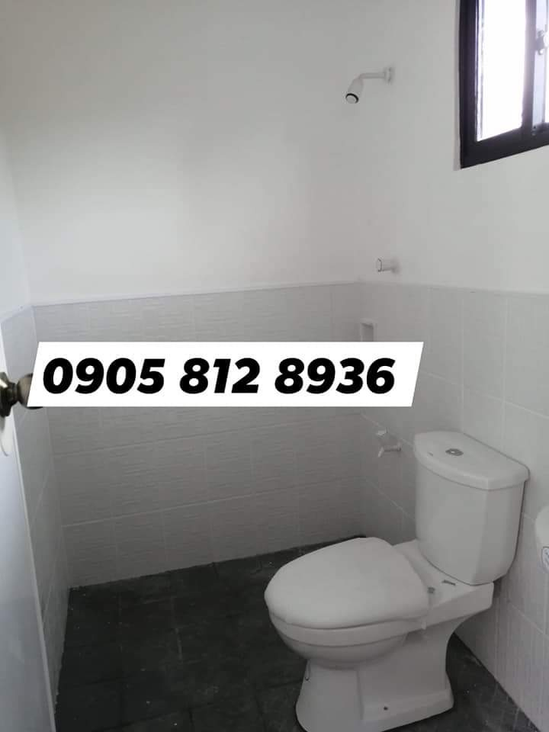 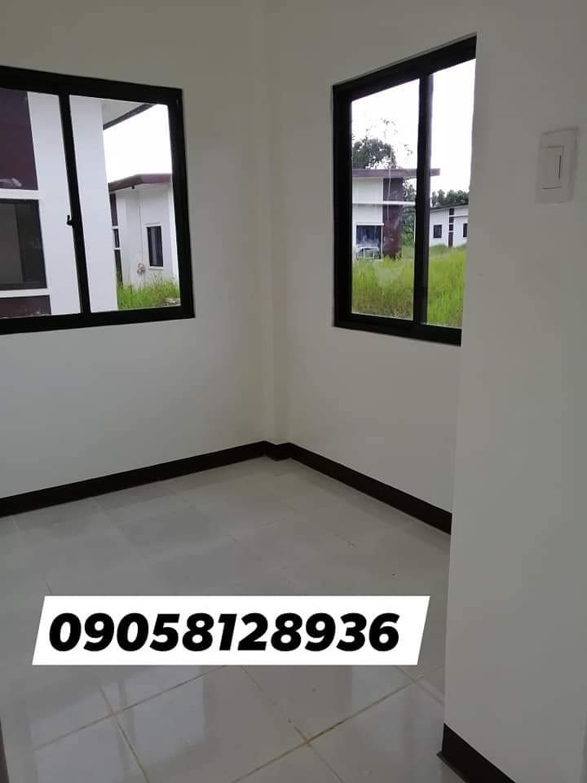 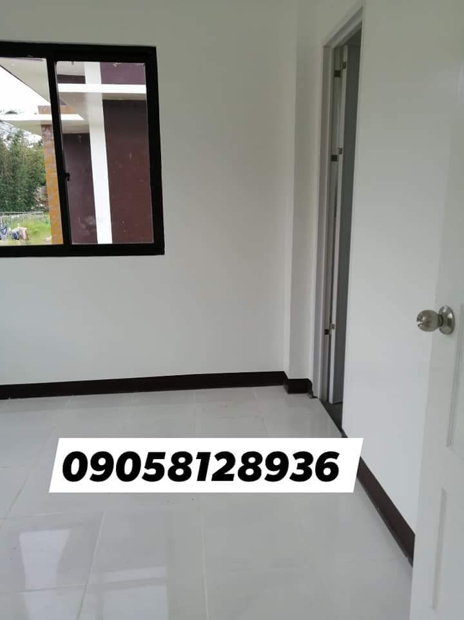

FOR ASSUME: House and Lot

Lot Area:150sqm

* 3 bedrooms
* 2 toilet and bath
* Status: for construction
* Estimated Monthly Amortization to pag ibig : 10,745 in 30yrs

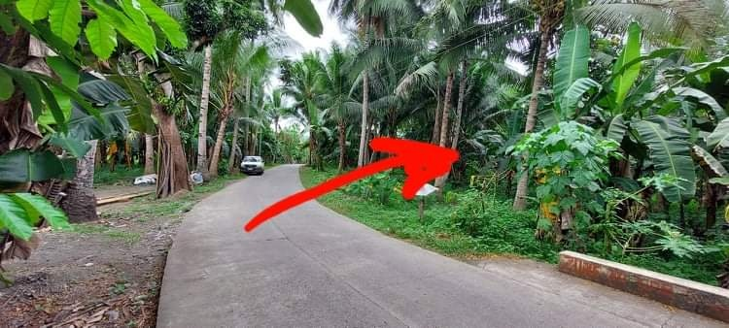

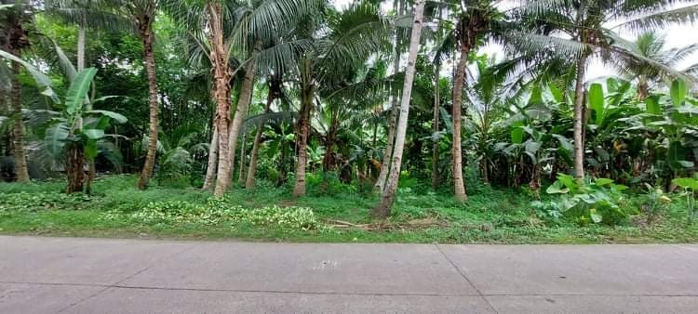

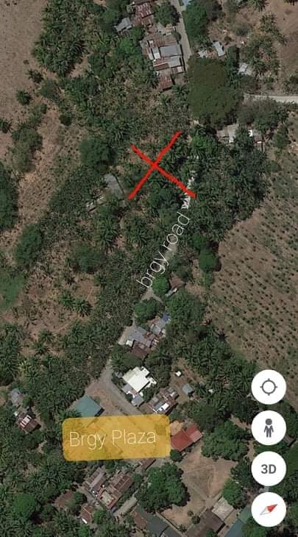 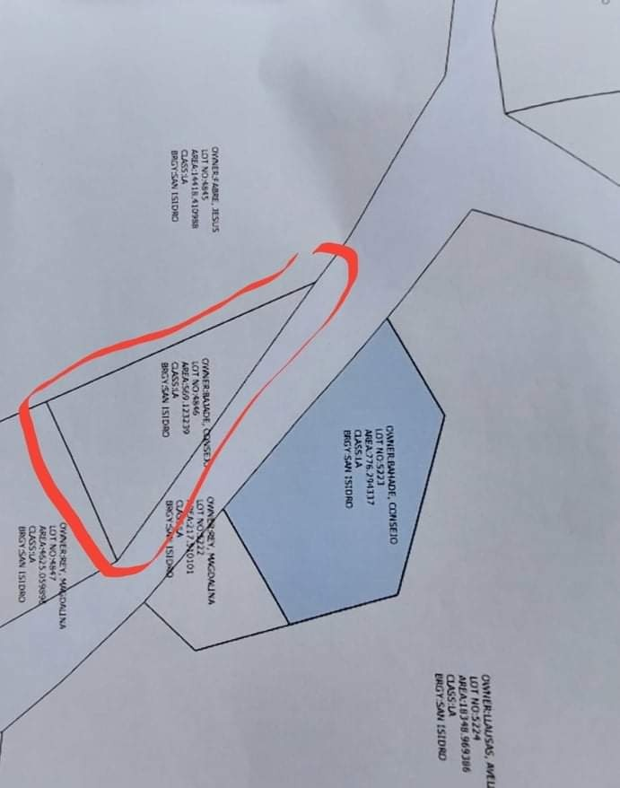

LOT FOR SALE!

Location: San Isidro, Balingasag

Lot Area: 547sqm

* Near barangay Hall/Plaza
* 600m away from Bria Homes
* Along side barangay road just 5 minutes away from national highway/Gaisano/Prince Hypermart/Bus terminal

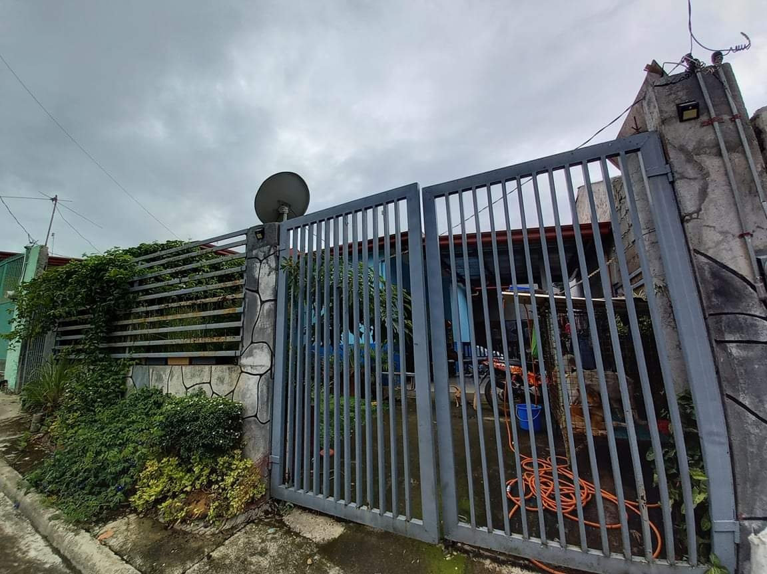 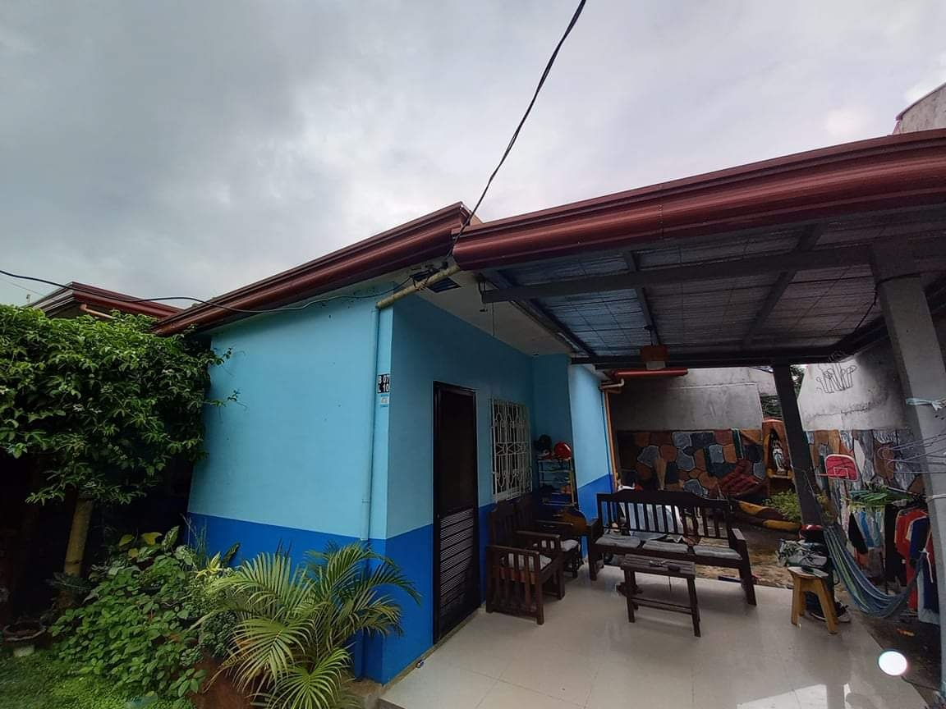

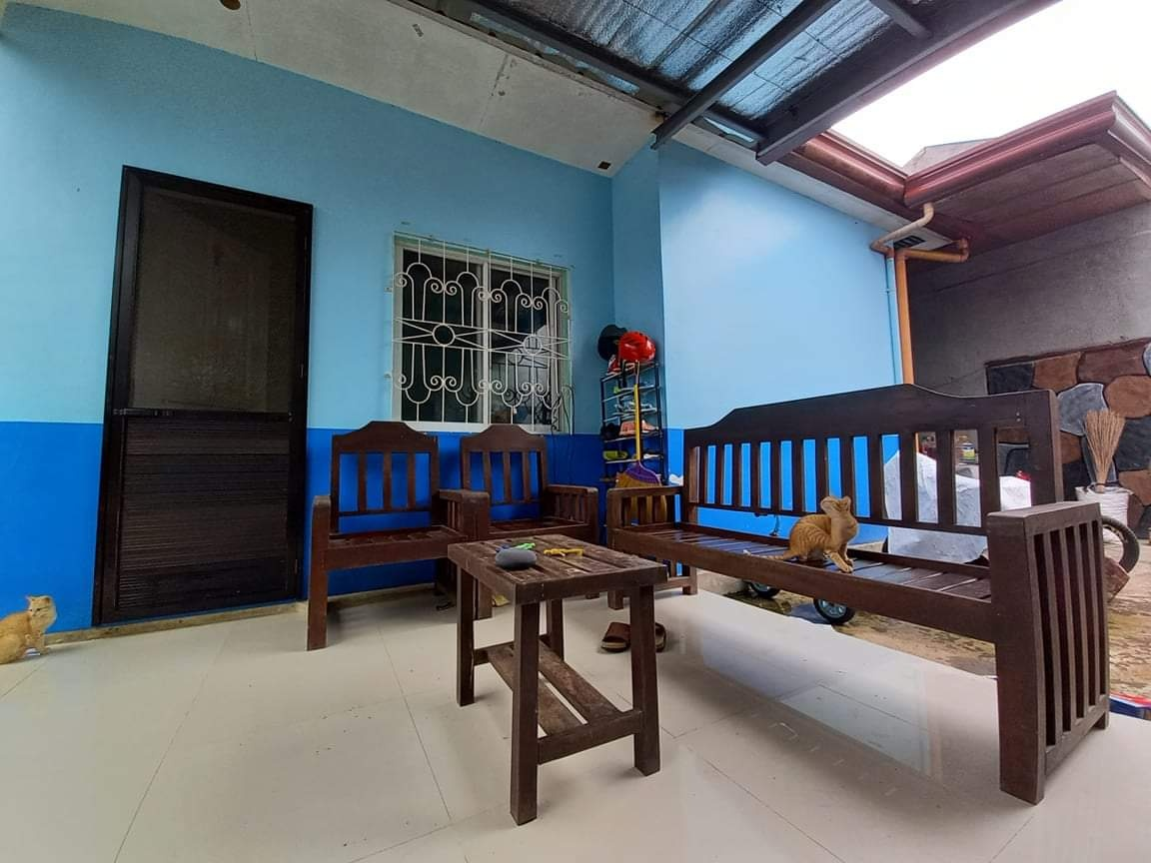 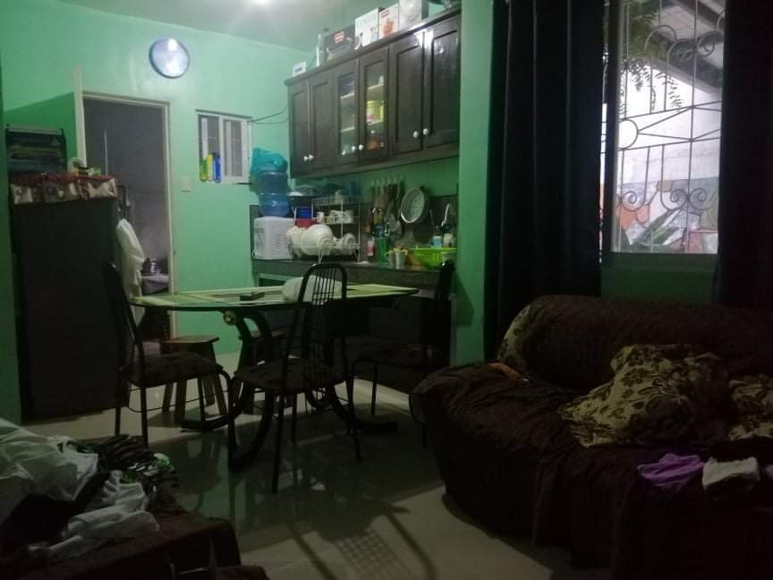

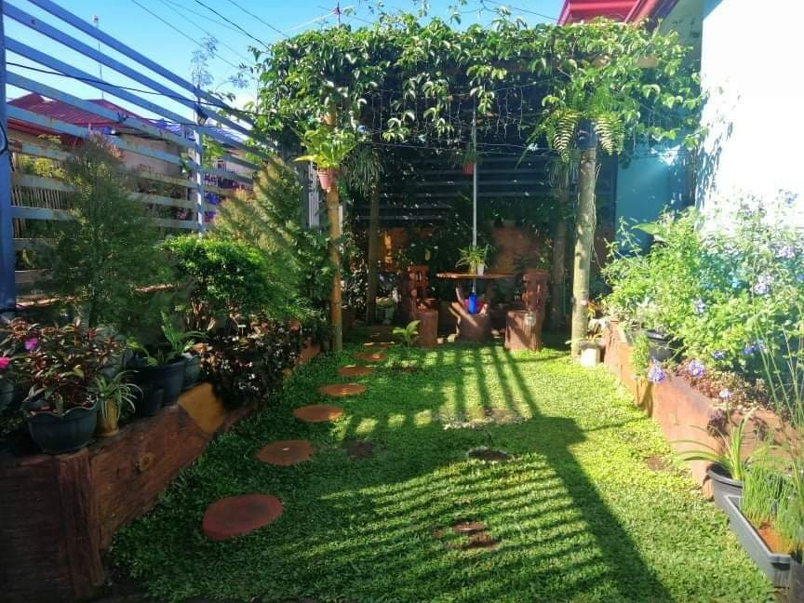

FOR ASSUME: House and Lot  
Location: Midland Valley Homes Kalasungay, Malaybalay City

* Ruby Model
* 2 bedroom
* 1 toilet
* Lot Area: 120sqm
* Floor: 40sqm
* Inside a gated subdivision with 24 hrs guard on duty
* With parking area
* Fully Fenced
* With garage
* With landscaped garden & Gazebo
* Monthly to pag ibig : 6,600